SIT103

Data and Information Management

Yizheng He

221411294

Learning Summary Report

Self-Assessment Details

The following checklists provide an overview of my self-assessment for this unit.

|  |  |  |  |  |
| --- | --- | --- | --- | --- |
|  | Pass (D) | Credit (C) | Distinction (B) | High Distinction (A) |
| Self-Assessment |  | ✓ |  |  |

Self-Assessment Statement

|  |  |
| --- | --- |
| Checklist | Included |
| Learning Summary Report | ✓ |
| All tasks required for the target grade completed | ✓ |
| Evidence of any additional task(s) or activities completed | ✓ |

# Declaration

I declare that this portfolio is my individual work. I have not copied from any other student’s work or from any other source except where due acknowledgment is made explicitly in the text, nor has any part of this submission been written for me by another person.

Signature: **Yizheng He**

# Portfolio Overview

Start with a statement as

“This portfolio includes work that demonstrates that I have achieve all Unit Learning Outcomes for <SIT103> <Data and Information management> to a **<Credit >** level.”

Describe your learning journey – where did you start, what did you learn, where will this take you? Note the significant milestones or hurdles you overcame **that help you demonstrate your achievements.**

When I started learning MYSQL, I found that its definition of the relationship with data is fundamental to building a database. For example, when I tried Credit Task 4.2 and 7.2, I found that if I didn't have a good ERD to draw the relationship between a database list, it would take a lot of time and effort to troubleshoot when there is an error, even though my programming skills are very good, if I don't have a good ERD diagram to support me to build a database. So for the first five weeks of the course, I not only watched the lectures, but I also taught myself the MYSQL database language on Collage and practiced a bit. Not only that, but in the quiz, I got good grades in both quizzes and passed them. Secondly, when the tutor pointed out my mistakes, I was able to fix them and finish them in time. I didn't waste a lot of time relearning, which is why I think I was able to get a credit grade.

# Reflections

## The most important things I learnt:

In this unit, first learn what a database is, its user data and metadata definitions, file system and database life cycle, etc. and learn about the data needs of the system and the importance of design. This is followed by database design concepts and logical design, relational model - entities, attributes, relationships and constraints.

Keys (composite keys, super keys, candidate keys, primary keys, natural keys, proxy keys, foreign keys, secondary keys)

Integrity rules, entity and referential integrity Entity-relationship diagrams and associated entities.

Attribute types Simple and composite attributes, single and multi-valued attributes, strength of relationships, weak and strong relationships.

Entity types, regular and weak entities.

Implementing Relationships Foreign Keys Associated Entities Extended/Advanced ERD Concepts Specialized/Generalized Relationships Hypertyped and Subtyped Entities.

Legacy databases, abnormal inserts, abnormal updates, abnormal deletes, abnormal functional dependencies

Normalization, First Paradigm (1NF), Second Paradigm (2NF), Third Paradigm (3NF). Non-normative

Database Design Strategy

DBMS Software Selection

Introduction to SQL - DML, DDL, TCL and DCL Commands

DML Commands - SELECT Query

FROM, WHERE, ORDER BY, GROUP BY, HAVING, AS, DISTINCT

Arithmetic, comparison, logical, and special operators Wildcards Aggregate functions Subqueries

Relational algebra union, intersection, difference, product, selection, item

Joining multiple tables Inner join, outer join

SQL Functions Data/Time Functions, Numeric Functions, String Functions Data Definition Language (DDL)

Create Table Create View Change Table Delete Table

Data Manipulation Language (DML) Insert Update Delete

Advanced SQL - PL/SQL Anonymous PL/SQL Blocks

Stored Procedures Cursors PL/SQL Functions Triggers

Operations and Decision Support Data Business Intelligence

Data Warehousing and Data Marts

Data Analytics and Data Mining

Data Visualization

Big Data NoSQL Database Data and Database Security Confidentiality

## I feel I learnt these topics, concepts, and/or tools really well:

Week 4 - Database Normalization and Week 7 - SQL. data definition commands and more data manipulation commands.

So far I have some confidence in building a mini database, I used up to nine tables to build my database in tasks 4.2 and 7.2, and it was approved by my tutor.

## I found the following topics particularly challenging:

I found Task 8.2D and 9.2D to be very challenging and I was very interested in learning these new languages on my own, which I had mastered and could do. Unfortunately, I had to work 30 hours a week so that I didn't have enough time or energy to study, so I had to choose my grade of C.

## I found the following topics particularly interesting:

I found Task 8.2D and 9.2D to be very challenging and I was very interested in learning these new languages on my own, which I had mastered and could do. Unfortunately, I had to work 30 hours a week so that I didn't have enough time or energy to study, so I had to choose my grade of C.

## I still need to work on the following areas:

For now, I plan to use what I learned this semester to build a database for storing daily expenses, mainly based on the three major directions of life, work, and study, and then carry out small branches for subdividing the categories. This will consolidate my knowledge and allow for some practice, and even make a small project for subdivision.

## The things that helped me most were:

Helped with the club meetings and the tutor answered my questions in detail and patiently. Enabled me to understand the content quickly

## My progress in this unit was …:

Complete weekly assignments on time and research relatively difficult assignments, ask your instructor, and consult relevant materials to complete them. Use memos to keep track of the tasks you need to complete each week and the tasks you are about to start.

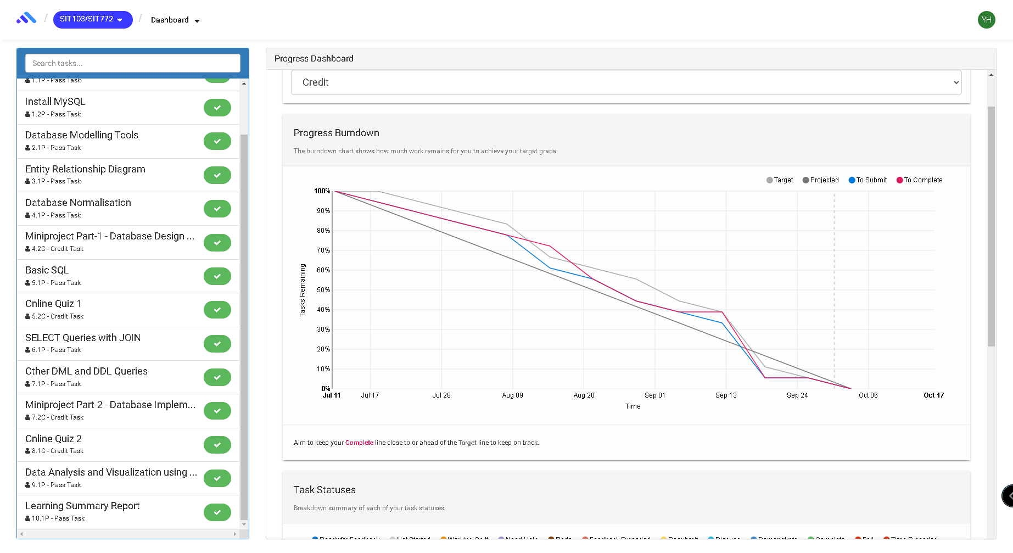

## If I did this unit again, I would do the following things differently:

If I were to relearn, I would focus on advanced SQL - PL/SQL Anonymous PL/SQL blocks, stored procedures Cursors PL/SQL functions Triggers and building a web page to collect data and store it in a database for greater success

## Other…:

Basic knowledge of MYSQL and the ability to build databases and write PHP, HTML

PL/SQL and other languages to support or extend the use of the database